**PET STORE USER MANUAL**

**Name: Likhith Chinnam**

**Student ID: 800986749**

**TITLE OF WEBSITE:PETSTORE**

**WELCOME PAGE:**

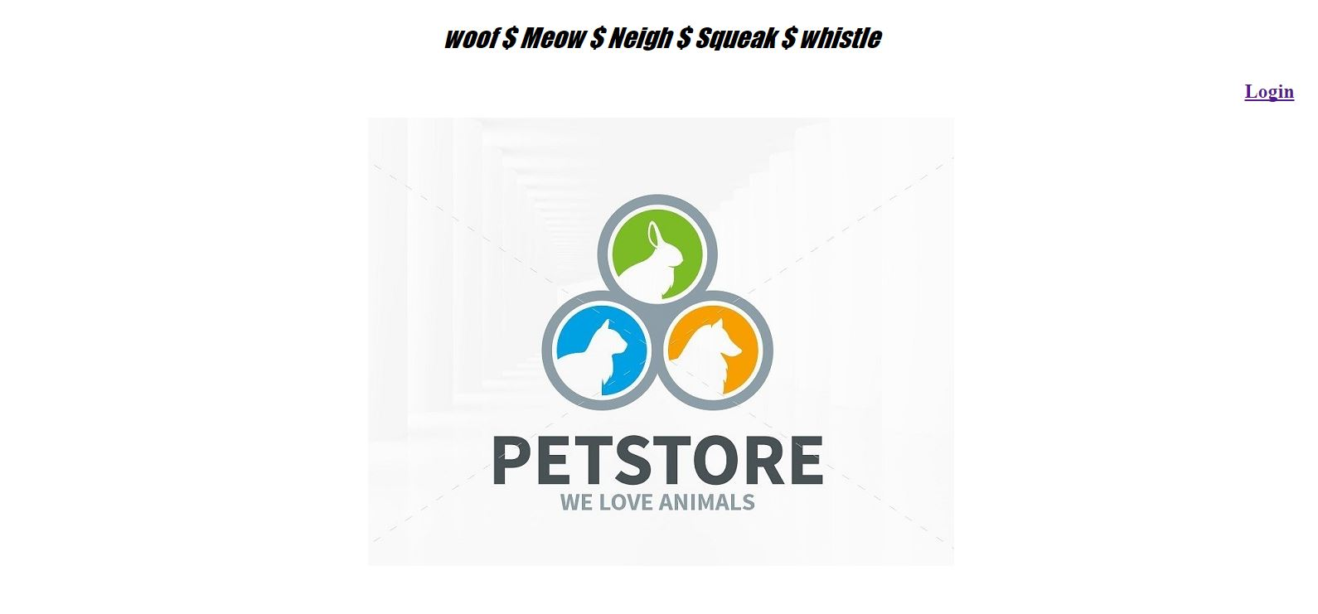

This the welcome page of the website. clicking on the login button will take you to the next page of the website.

There must be proper internet connection Inorder to view the website correctly.

**LOGIN PAGE**

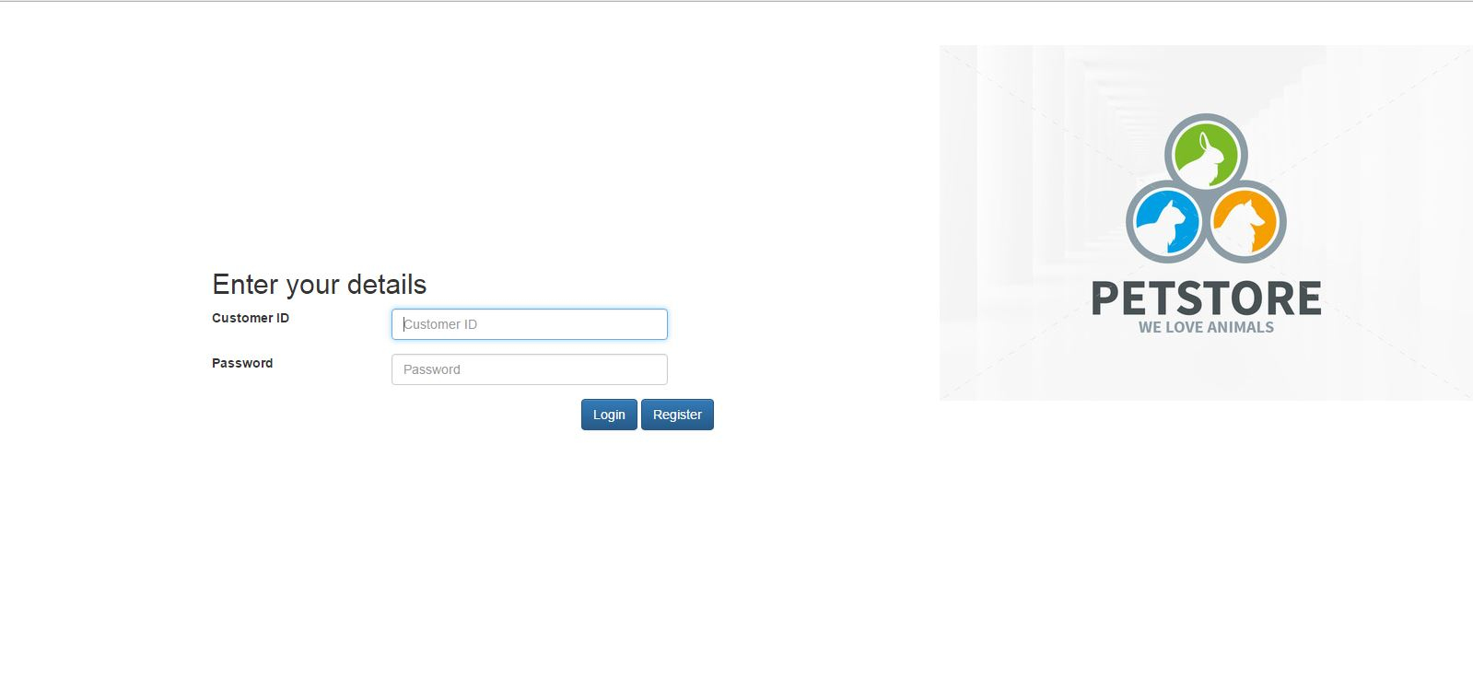

This is the Login Page, If you are Already Registered then you can Login, Otherwise You have to signup as New User.

**SIGNUP PAGE**

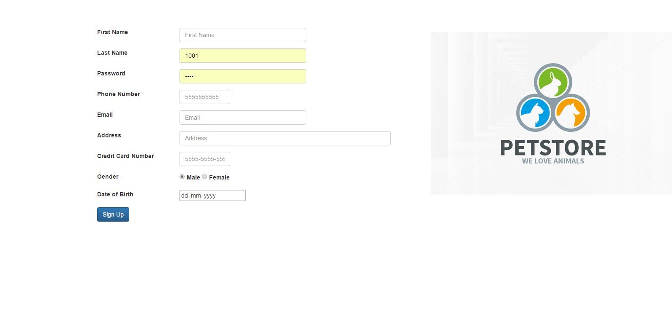

**CATEGORY PAGE**

After Logging in, You have to Choose Among the Categories Dog, Horse, Cat, Rabbit, Fish

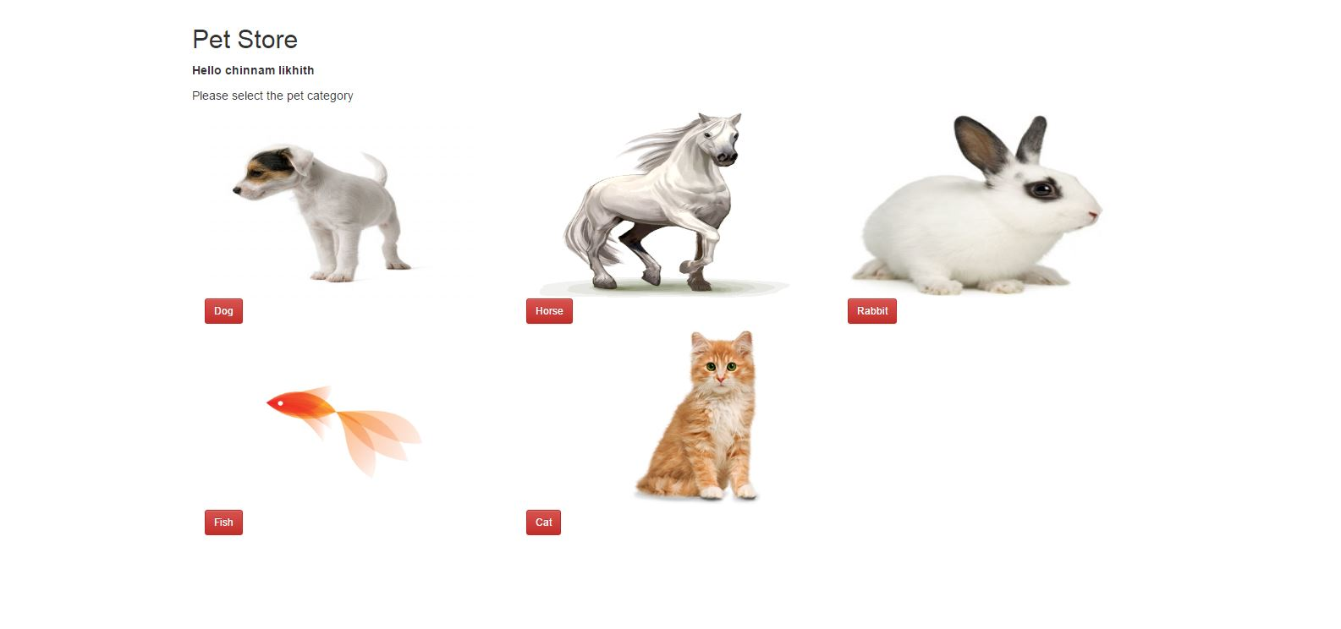

**PRODUCT SUMMARY**

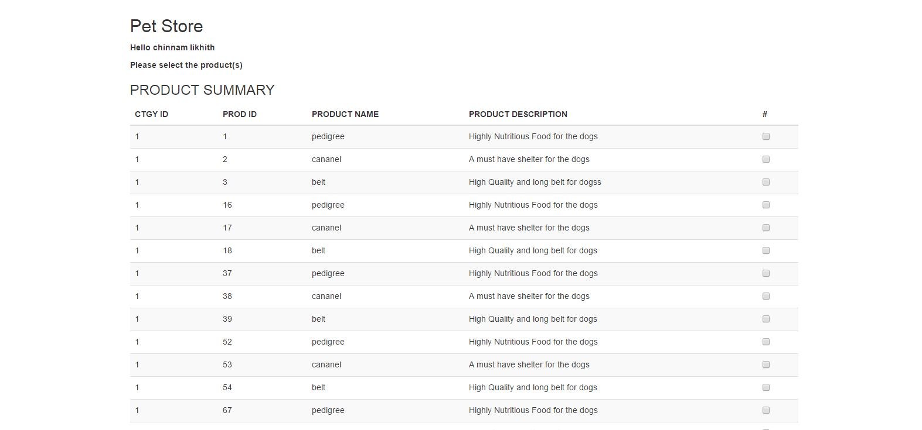

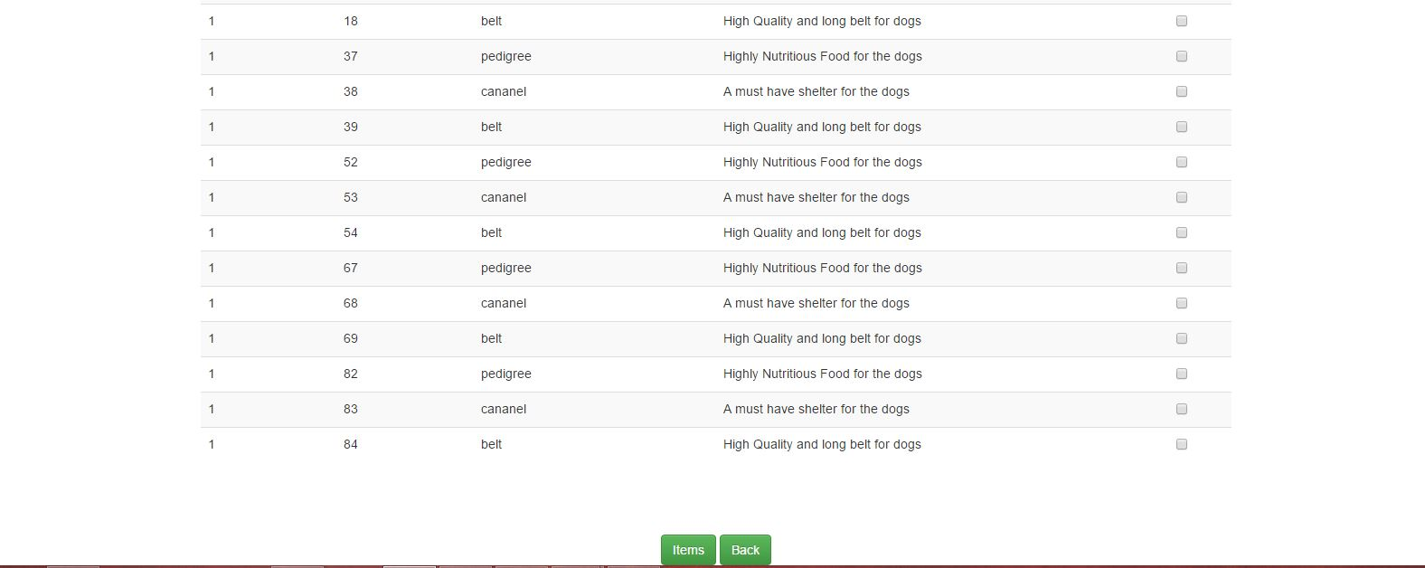

AfterSelecting Category, You have to Select Among the Listed Products and click on Items button to proceed to Next Page Or you can go back to Categories Menu.

**ITEM SUMMARY**

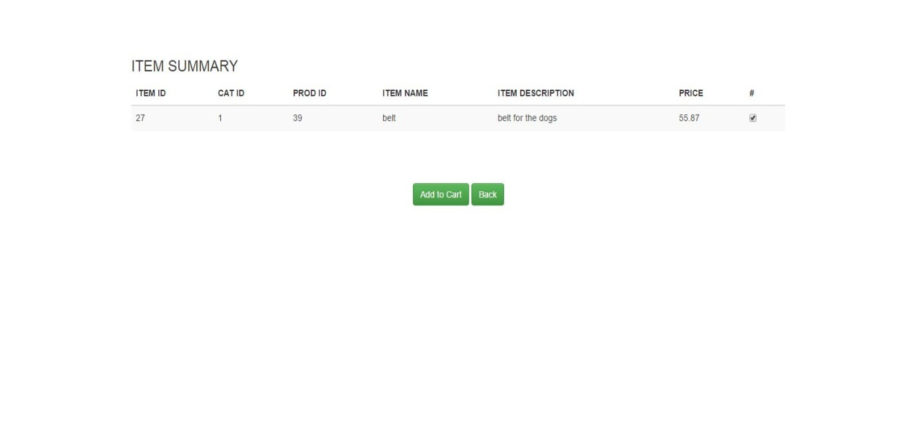

In this page you will get item summary, Now you can add them to Cart or go back to last page by clicking on buttons.

**CART SUMMARY**

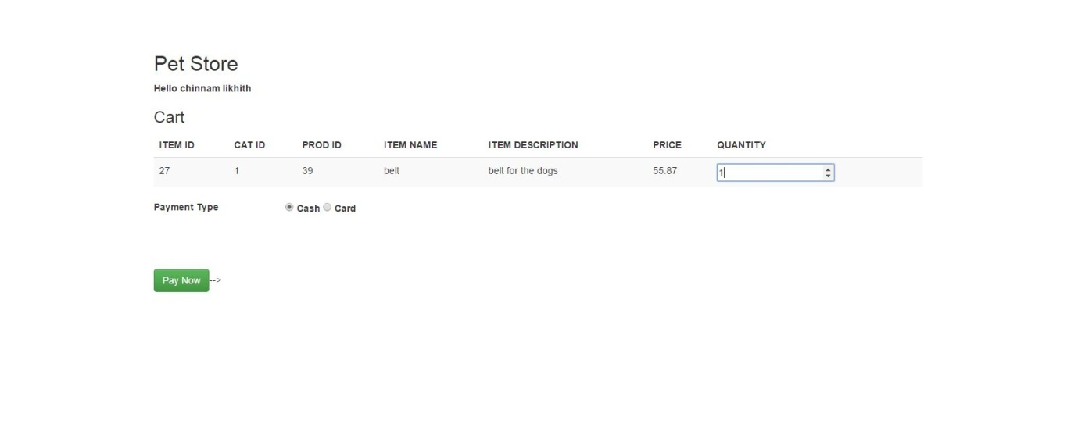

You can select the Quantity and payment mode in this page clicking on pay now button you will move to next page.

**PURCHASE SUMMARY**

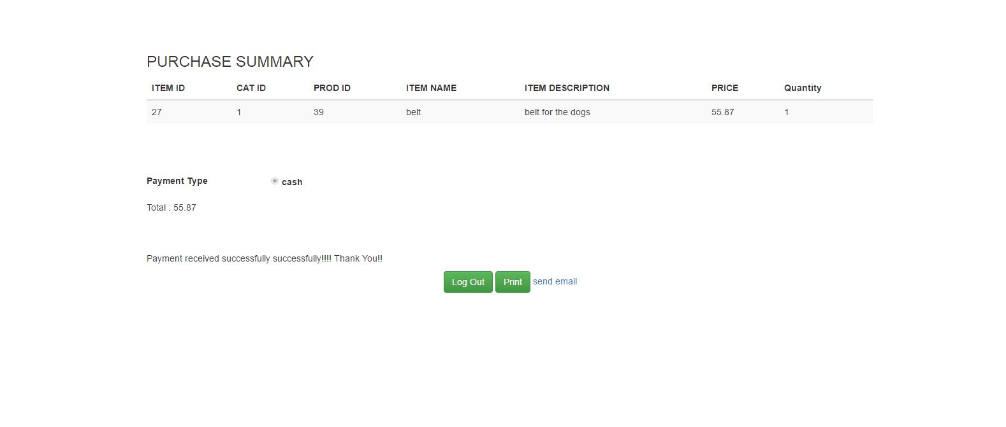

In this page you can choose to print the purchase summary. You can send an email to your account regarding the purchase on clicking on Logout you will go back to Home page.

**Admin** has the functionality to Update the price List of the products.

**Some Common Problems and solutions**

* You will get Problems when you type an incorrect website name. So you should be careful while entering the Url in your browser.
* You will face errors with Login Page if you don't give correct credentials. You must be careful while entering details.
* You will face errors like you Can't see the images in the website. You must have Internet will be reasonable speed in order to see the website Clearly.
* Email Problems If you don't enter correct email address
* These are some of the common Problems you will face will Accessing the Website..